Specification:
The system to be designed will be a relational database management system that is capable of storing information required for multiple formula 1 championships. It will contain the following entities:

- Driver
- Team
- Race Record
- Race
- Competition (ie,championship)
- Circuit

The system must be able to allow access to the following information:

- Driver
  - Name
  - DOB
  - Team
  - Race times
  - Competitions entered

- Team
  - Team name
  - Location
  - Team Members

- Race
  - Date of race
  - Time of race
  - Race Circuit
  - Competition the race is a part of

- Circuit
  - Circuit name
  - Location

- Competition
  - Competition name
  - Circuits in competition
  - Race results for competition.

The system must be able to perform the following functions:

- Add / Remove a driver
- Add / Remove a Team
- Add / Remove a circuit
- Add / Remove a competition
- Record the results of a race
- Display competition results / Calculate winner.
- Display any information stored in the database as stated above.
Assumptions:
I have assumed the following:

- A driver may only belong to one team
- A team may have multiple drivers
- A driver may not enter more that one race on a given day.

Table Normalisation:

From the initial description I deduced the following structure with the following functional dependencies:
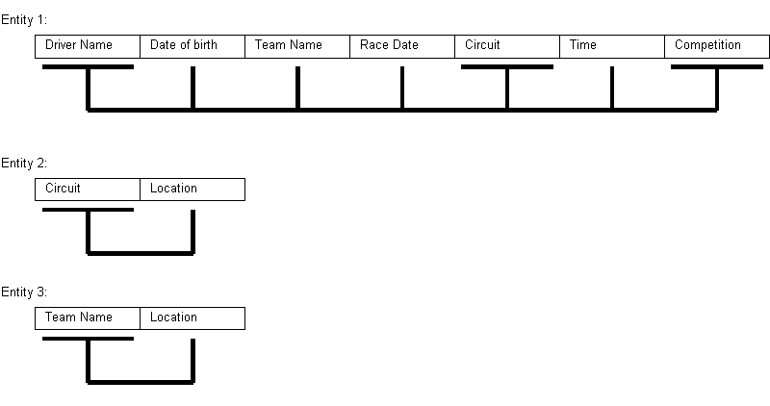
Entity 1. From the driver name, the circuit and the competition you can determine all other attributes.
Entities 2 and 3 are already in BCNF so require no more work. These entities will be the “Circuit” and “Team” entities. Entity 1 is in need of normalisation:

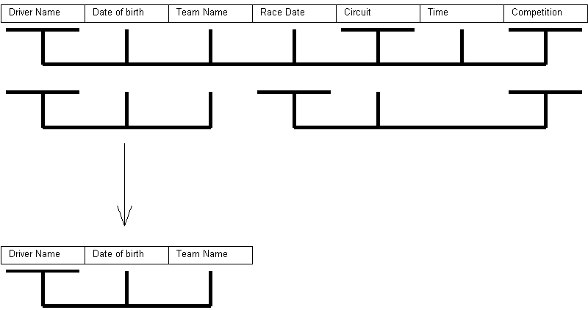
From this initial normalisation we now have another entity in BCNF. This will be the “Driver” entity.

The remaining table still needs further normalisation:
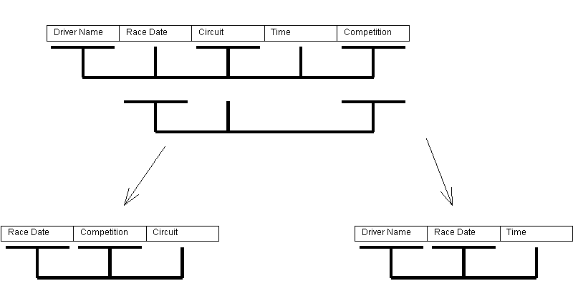
By normalising to this point we now have two entities that are in BCNF. These entities are the “Race” and “Race Record” entity. So the result is 5 BCNF entities:

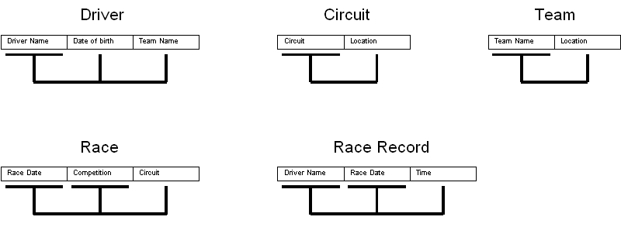
With the above structure we are able to avoid all update, insert and delete anomalies. The only issue I can see with this is that you may want to add a competition without assigning a race to it. That is why I have decided to add an additional entity called “Competition” and have it referenced to in “Race”. With this in mind the final ERI diagram can be constructed.

RI Diagram:

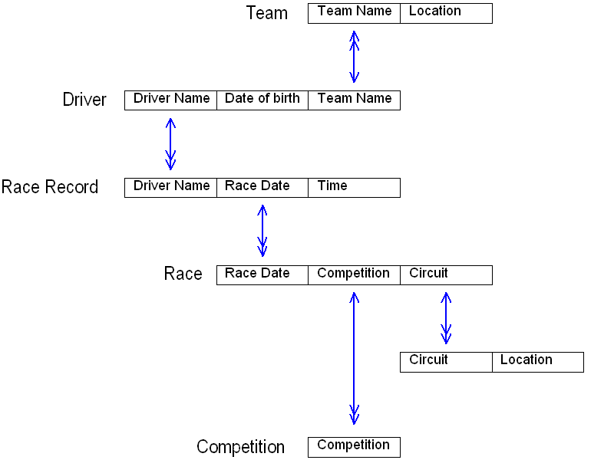

EAR Diagram

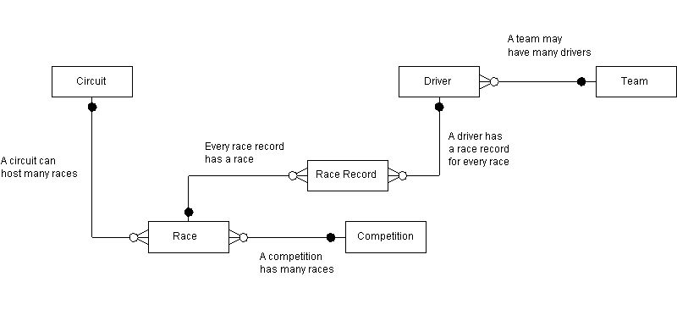

Details of entity attributes:

Driver(Driver Name, Date of birth,Team Name)
Race Record(Driver Name, Race Date, Time)
Race(Race Date, Competition,Circuit)
Circuit(Circuit Name, Location)
Competition(Competition)
Team(Team Name, Location)

